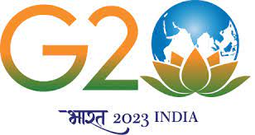
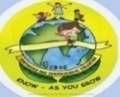
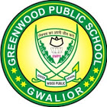
GREENWOOD PUBLIC SCHOOL, ADITYAPURAM
OUR MOTTO - DEVELOPMENT WITH DELIGHT
SYLLABUS FOR PERIODIC- II + TERM II (2023-24) FOR CLASS-I

SUBJECTS | BOOKS | LESSONS | SKILLS | ACTIVITY+USE OF ICT | PARENTS INVOLVEMENT
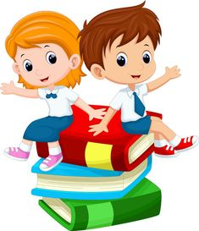  ENGLISH | Longman New Images Literature | PD-II  L-7 Happy feet  TERM-II  L-9 Who will be the king  L-11 Friends in Need. | Read, Understand Pronunciation Clarity | ICT – Extramarks  (All topics to be covered up on Extramarks)  Multiple Assessment:  Task- Reading + Recitation  Subject Enrichment:  Task – ASL  Dialogue Conversation | Give Your Child Regular Loud Reading Practice.
 | Writing Skills | PD-II Writing Sentences based on the given pictures, Paragraph- My Mother  TERM-II Paragraph- My favourite festival, Sick Leave Application, Sequencing the given story | Effective writing communication, Spelling, Handwriting, Vocabulary |  | Encourage your child to write in neat and clean handwriting
 | Speaking Skills | Dialogue Conversation Topic-My Country | Discuss, Listen, Concentrate
 | Grammar Learnwell Smart | PD-II  L-7 Negatives and Questions  L-8 Yes/No Questions.  Definition of verb  TERM-II L-9 Place Words  L-10 Use of has/have  L-11 Action Words  L-12 Composition (Picture Reading)  Definition of Adjective, Jumbled Sentences | Comprehend  Identify  Recall. |  | Help your child to speak in English at home also.
 | Group Recitation | PD-II L-10 How many seconds in a minute  TERM-II L-12 Opposite Day | Recite, Appreciate
 | Reading  Skills | PD II + TERM- II  Reading Comprehension. |  |  | Help your child in learning poems.

SUBJECTS | BOOKS | LESSONS | SKILLS | ACTIVITY+USE OF ICT | PARENTS INVOLVEMENT
HINDI | mUes’k | PD-II ikB&8 prqj fpfM;k  ikB&9% fpfM;k vkbZ ikuh ihus]  ikB&10% HkkYkw Uks dku es D;k dgk  TERM-II ikB&11% isM ikB&12% fyax] ikB&13% ,d vusd  ikB&14% fxurh | mPpkj.k {kerk] izokg | ICT – Extramarks  (All topics to be covered up on Extramarks)  Multiple Assessment:  Task-1: Reading  Task-2: Recitation  Subject Enrichment:  Task-1: Listening Skills  Task-2: Speaking Skills  Topic-esjk fç; [ksy | dfBu 'kCn cksydj fy[kok,a
 | iBu dkS'ky | ikB] iBu] vifBr x|ka'k | cks/kxE;rk |  | izfrfnu ,d ist i<+us dk vH;kl djok;sa ,ao ikWp “kCn cksydj Jqrys[k fy[kok,a
 | ys[ku dkS'ky | PD-II esjk fo|ky;] esjk fiz; R;ksgkj] fp= ys[ku  TERM-II] izkFkZuk i=] okD;ksa dks lgh Øe esa fyf[k,] | vfHkO;fDr Lrj] 'kCnp;u
 | ekSf[kd {kerk | PD-II dfork&1- fpfM+;k vkbZ ikuh ihus  TERM-II dfork & 1- isM+ | Lej.k 'kfDr] vkRefo'okl |  | dfork ;kn djok,¡
 | Jo.k {kerk | dgkuh lqukdj ç'u iwNuk | fo’k; dh le>] ,dkxzrk |  | dgkuh lqukdj cPpksa ls iz'u iwNs
 | O;kdj.k | PD-II fØ;k] foykse 'kCn] fyax] opu] i;kZ;okph  TERM-II fo'ks’k.k] foykse 'kCn] fyax] opu] i;kZ;okph] vusd 'kCnksa ds fy, ,d 'kCn] 'kCnksa dks lgh Øe esa yxkb, | O;kdjf.kd Kku] Hkkf"kd Kku |  | fØ;k ,oa fo'ks’k.k dh ifjHkk’kk fy[kdj ;kn djok,¡
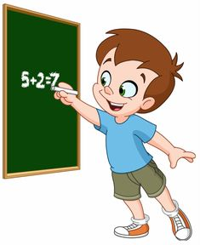  MATHEMATICS | Learnwell Smart Mathematics | PD-II  L-7 Numbers from 21 to 100  L-8 Measurement  L-9 Time  TERM-II  L-10 Money  L-11 Data Handling  L-12 Patterns  L-13 Road to Multiplication | Identify, Build  Logical Thinking,  Decision Making  Fun with Abacus students will add and subtract the given numbers using abacus. | ICT – Extramarks  (All topics to be covered up on Extramarks)  Art Integrated Activity:  - Clock by using colourpaper.  Multiple Assessment:  Task-1: Mental Maths  Task-2: Quiz on Tables  (2-10) and Time.  Subject Enrichment:  Task-1: Lab Activity  Lab Activity-Pg No.97, 121,147 | Help your child in learning tables.
SUBJECTS | BOOKS | LESSONS | SKILLS | ACTIVITY+USE OF ICT | PARENTS INVOLVEMENT
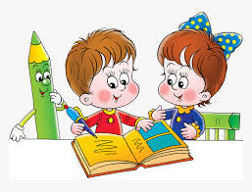  E.V.S. | The World For You And Me | PD-II  Unit-3 : PERSONAL HYGIENE AND SAFETY  L-8 Good Manners and Healthy Habits  L-9 Our safety  TERM-II  Unit- 4 : OUR SURROUNDINGS  L-10 Our Green Friends  L-11 Animals Around us  Unit-5 TRANSPORT  L-12 Moving around  Unit-6 THE WORLD AROUND US  L-13 The sky and Weather | Self Awareness, Critical Thinking And Analysis | ICT – Extramarks  (All topics to be covered up on Extramarks)  Multiple Assessment: Quiz  Topic- Transport  Subject Enrichment: Lab Activity  Ch-10 Our Green Friends  - Growth of plants with sunlight  Reaction of plants without sunlight  Brain café Activity :  Ch-11 Animals Around us | - Give your child regular loud reading practice.  - Take your child to zoo.
COMPUTER | Cyber Beans | PD-II L-5 Using a Keyboard  L-6 Fun with paints  TERM-II  L-7 Data and storage  L-8 Introduction to scratch | Observation Interpretation | Lab Activity S.E. -  Ch-5: How to use a Keyboard?  Ch-6: Introduction to paint program | M.A.  Quiz
ART & CRAFT | Art & Activity | Hut, Fruits | Exploration, Creative expression | - | 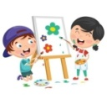  -
G.K. | Be A GK Champ | PD-II Nature and Wildlife [Page No. 26 to 27],  India [Page No. 28 to 30], Sports [Page No.31 to 32]  TERM–II Science and Technology [Pg No.33-35]  World Around Us [Page No.36 & 38]  Literature and Language [Page No. 39 to 41]  Art and Entertainment [Page No. 42 to 43]  Mixed Bag [Page No. 44 & 46]  Problem Solving [Page No. 47 to 49] | General Awareness | ICT – Extramarks  (All topics to be covered up on Extramarks) | Motivate your child to read English and Hindi news paper

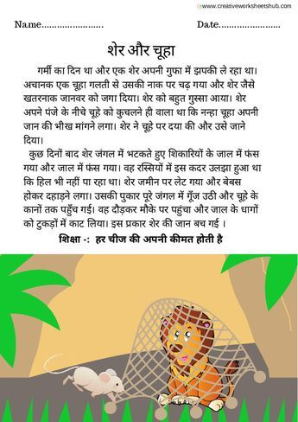
MORAL:
WORK HARD AND REACH YOUR GOALS.
GREENWOOD PUBLIC SCHOOL, ADITYAPURAM
OUR MOTTO - DEVELOPMENT WITH DELIGHT
SYLLABUS FOR PERIODIC-II + TERM –II (2023-24) FOR CLASS-II
SUBJECT | BOOKS | LESSONS | SKILLS | ACTIVITY+USE OF ICT | PARENTS INVOLVEMENT
ENGLISH | Longman New Images  Literature | PD-II  Ch-9 Naren’s Kindness  TERM-II  Ch-10 Maths for the Dance Drill  Ch-12 The Merchant of Seri | Read, Understand. Pronunciation, clarity  Effective Writing communication, spelling, Handwriting vocabulary | Multiple Assessment:  Task-1: Reading  Task-2: Recitation  Subject Enrichment:  Task-ASL  ICT – Extramarks  (All topics to be covered up on Extramarks) | Encourage your child to read story books and English newspaper  Encourage your child to write in neat and clean handwriting
 | Writing Skills | PD-II: Fee Concession Application, Paragraph Writing: My Country, Writing Sentences based on the given pictures  Term-II: Paragraph Writing : Importance of games, Sequencing the given story
 | Speaking Skills | Dialogue Conversation  Topic- My Best Friend
 | Grammar  Learnwell Smart | PD-II: Ch-9 Orders and Requests  Ch-10 Question Words  Term-II  Ch-11 There and It  Ch-12 Possessives, Ch-13 Subject verb object, Ch-14 Singular and plural verbs,  Ch-15 Negatives and Questions,  Jumbled Sentences
 | Group Recitation | PD-II:Ch-8 The Rainbow  Term-II:Ch-11 Two Little Kittens | Recite, Appreciate |  | Help your child in learning poems.

SUBJECT | BOOKS | LESSONS | SKILLS | ACTIVITY+USE OF ICT | PARENTS INVOLVEMENT
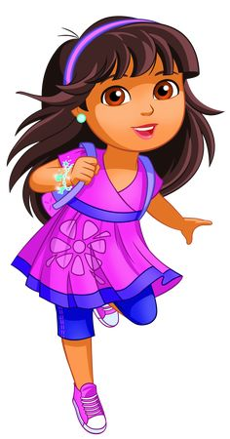  HINDI | mUes’k | PD-II ikB&9%LoPN] LoLFk jgsxsa] ikB&10% vPNs cPps] ikB&11% jax tek;k Vh]Okh us  TERM-II ikB&12% Hkwr] ikB&14% eSa gwWa NqbZ&eqbZ] ikB&15% cgqr t#jh ckrsa | mPpkj.k izokg | ICT- Extra Marks  (All topics to be covered up on Extramarks)  Multiple Assessment:  Task-1: Reading  Task-2: Recitation  Subject Enrichment:  Task-1: ASL | izfrfnu ,d ist i<+us dk vH;kl djok;saA
 | iBu dkS'ky | ikB iBu] vifBr x|ka'k | cks/kxE;rk |  | ikB i<+kus dk vH;kl djok;sa
 | ys[ku dkS'ky | PD-II vuqPNsn&esjk ?kj] [ksyksa dk egRo  TERM-II izkFkZuk i=] fp= ys[ku] okD;ksa dks lgh Øe esa fyf[k, | vfHkO;fDr Lrj] 'kCn p;u |  | dfBu 'kCn cksydj fy[kok,a
 | ekSf[kd {kerk | PD-II ikB&8% dqgw&dqgw ] dkWo & dkWo]  [ksyksa dk egRo  TERM-II ikB&13% Vksih okyk vkSj canj | Lej.k 'kfDr] vkRefo'okl
 | Jo.k {kerk | dgkuh lqukdj ç'u iwNuk | fo’k; dh le>] ,dkxzrk |  | dfork ;kn djok,¡ ,oa dgkuh lquk,¡ ,oa mlls lacaf/kr ç'u iwNsA
 | O;kdj.k | PD-II fØ;k] fyax] opu  TERM-II laKk] loZuke] fo'ks’k.k] fyax] opu] 'kCnksa dks lgh Øe esa yxkb, | O;kdjf.kd Kku + Hkkf"kd Kku
MATHEMATICS | Learnwell Smart Mathematics | PD-II  Ch-8: Shapes  Ch- 9: Patterns  Ch-10: Measurement  TERM-II  Ch-11: Time  Ch-12: Money  Ch-13: Data Handling | Identify,  Build Logical Thinking, Decision Making, problem solving | ICT – Extramarks  (All topics to be covered up on Extramarks)  Art Integrated Activity:  - Making 2D Shapes using coloured paper.  Multiple Assessment:  Task-1: Mental Maths Quiz  Task-2: Quiz on Tables 2-10  Subject Enrichment:  Task-1: Represent the different numbers using pictures.  Task-2: Lab Activity  LAB ACTIVITY  Page No. 126,136,151,163,175,185 | Help your child in learning tables

SUBJECT | BOOKS | LESSONS | SKILLS | ACTIVITY+USE OF ICT |  | PARENTS INVOLVEMENT
E.V.S. | The World For You and Me | PD-II  Unit-IV THE WORLD WE LIVE IN  Ch- 8 Air and Water  Ch- 9 Nature and land Around us  Ch-10 The sky and the seasons  TERM-II  Unit-V: TRANSPORT AND COMMUNICATION  Ch-11 Transport and communication  Unit-VI: TIME SPACE AND DIRECTIONS  Ch-12 Time  Ch-13 Directions | Self-awareness, critical thinking | ICT – Extramarks  (All topics to be covered up on Extramarks)  Art Integrated Activity-  - Draw any one landform that you see in your surroundings  - Making a collage of Important Road signs  - Making Direction Indicator  Multiple Assessment:  Task-1: Brain Cafe Activity  Topic- Time  Task-2: Quiz : Topic-The sky and the seasons |  | Watch the clouds move through the sky and study the clouds.
COMPUTER | Cyber Beans | PD-II  Ch-5 Storage Devices  TERM-II  Ch- 6 Drawing shapes in paint  Ch-7 More on paint  Ch-8 Coding with scratch | Observation, Interaction | ICT – Extramarks  (All topics to be covered up on Extramarks)  Ch-5: Identify the storage devices.  Ch-6 Draw and colour the different shapes  Ch-7 Use pencil tool, line and curve tools  Ch-8 Create an animated story in scratch Jr.  M.A. Task- Make a Poster on ‘Keep our surroundings clean in paint’. |  | Encourage your child to read about the world of AI  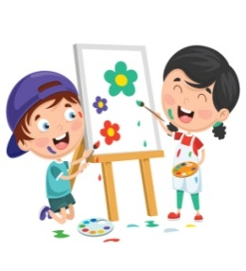
ART & CRAFT | Art & Activity | Fruits, Vegetables | Exploration, Creative expression
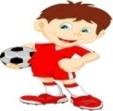  G.K. | Be A GK Champ | PD-1I Nature and Wildlife India, Sports  TERM-II Science and Technology, World Around Us, Literature and Language, Art and Entertainment, Mixed Bag, Problem Solving | General Awareness |  |  | Motivate your child to read English & Hindi news paper

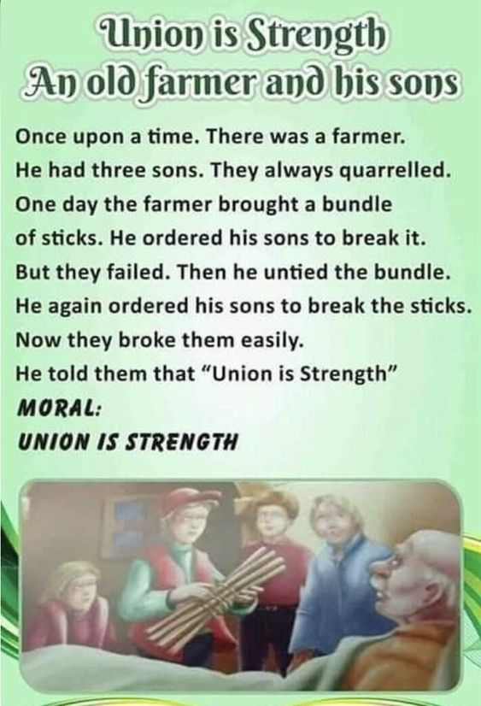
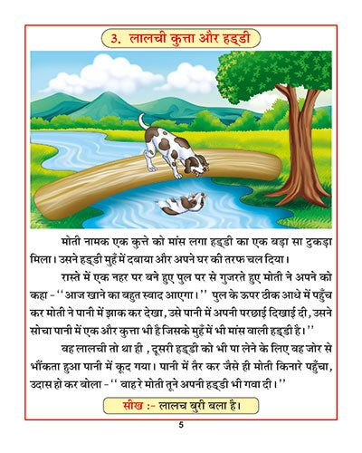
Once upon a time, there was a farmer. He had three sons. They always quarrelled. One day the farmer brought a bundle of sticks. He ordered his sons to break it. But they failed. Then he untied the bundle. He again ordered his sons to break the sticks. Now they broke them easily.
He told them that “Union is Strength”
MORAL:
UNITY IS STRENGTH

MORAL:
Unity Is Strength
GREENWOOD PUBLIC SCHOOL, ADITYAPURAM
OUR MOTTO - DEVELOPMENT WITH DELIGHT
SYLLABUS FOR PERIODIC-II+TERM-II (2023-24) FOR CLASS-III
SUBJECTS | BOOKS | LESSONS | SKILLS | ACTIVITY+USE OF ICT | PARENTS INVOLVEMENT
ENGLISH | Longman New Images  Literature | PD-II Ch-8 : Searching for the spirit of spring  Ch-9 : Festival Fiesta  Ch-10 : When Rusty played Holi  Term-II Ch-11 : Five little brothers  Ch-12 : The Happy prince  Ch-13 : Chulbul’s Tail | Read Understand Pronunciation Clarity & Comprehend Identify | ICT – Extramarks  (All topics to be covered up on Extramarks)  Multiple Assessment:  Task-1: Reading  Task-2: Recitation  Subject Enrichment:  Task-1: ASL | Encourage your child to read story books and English newspaper
 | Writing Skills | PD-II: Writing Sentences based on the given pictures, Letter to your friend inviting him/her to attend your birthday  TERM-II: Paragraph writing-Importance of Exercise, Sequencing the given story | Effective writing communication, Spelling, Handwriting, Vocabulary |  | Encourage your child to write in neat and clean handwriting
 | Speaking Skills | Conversation Topic- My Hobby | Discuss, Listen, Concentrate, Recall
 | Grammar  Learnwell Smart | PD-II Ch-7 Some special verbs  Ch-8 The use of V₁  Ch-9 The use of V₂  TERM-II Ch-10 The use of V³ , Ch-11 The use of will/shall, Ch-12 Yes/No Questions, Ch-13 Composition Writing and Comprehension, Jumbled Sentences | Comprehend,  Identify, Relate
 | Group Recitation | PD-II:- Festival Fiesta  TERM-II: Five Little Brothers | Recite, Appreciate |  | Help your child in learning poems with actions.
 | Reading Skills | Comprehension
SUBJECTS | BOOKS | LESSONS | SKILLS | ACTIVITY+USE OF ICT | PARENTS INVOLVEMENT
HINDI | mUes’k | PD-II  ikB&9 % Qy [kk,W]Lksgr cuk,W  ikB&10 % ,d t#jh ckr  TERM-II  ikB&12% tqxuw  ikB& 13% vDy cMh ;k HkSLk ikB&14 % isM dh ckrs ikB&15 % “ksj vkSj fiYyk | mPpkj.k {kerk] izokg | ICT- Extra Marks  (All topics to be covered up on Extramarks)  Multiple Assessment:  Task-1: Reading  Task-2: Recitation  Subject Enrichment:  Task-1: Listening Skills (Narration)  Task-2: Speaking Skills  Topic- le; dk egRo | çfrfnu ,d dgkuh lquk,¡ vkSj mlls lacaf/kr iz'u iwNsA
 | iBu dkS'ky | vifBr x|ka'k] vifBr i|ka'k] ikB iBu | cks/kxE;rk
 | ys[ku dkS'ky | PD-II vuqPNsn& ;ksxk dk egRo] lwpuk  TERM-II vukSipkfjd i=& laxhr izfr;ksfxrk esa pqus tkus ij fe= dks c/kkbZ i=] foKkiu&nkrksa ds fy, eatu gsrq ,d vkd’kZd foKkiu] laokn] fp= ys[ku] okD; dks lgh Øe esa fyf[k, | vfHkO;fDr Lrj] 'kCnp;u |  | izfrfnu ikB i<+ok,
 | ekSf[kd {kerk | PD-II dcwrj vkSj f”kdkjh ¼dfork½  TERM-II _rqvksa dk Ldwy ¼dfork½ | Lej.k 'kfDr] vkRefo'okl |  | dfork ;kn djok,¡
 | Jo.k {kerk | dgkuh lqukdj ç'u iwNuk | fo’k; dh le>],dkxzrk
 | O;kdj.k | PD-II dky] foykse 'kCn] i;kZ;okph 'kCn] vusd 'kCnksa ds fy, ,d 'kCn  TERM-II fojke fpUg] eqgkojs] 'kCnksa dks lgh Øe esa yxkb, | O;kdjf.kd Kku]+ Hkkf"kd Kku
MATHEMATICS | Learnwell Smart | PD-II Ch-9 Money  Ch-10 Measurement of length  TERM-II Ch-11 Measurement of weight , Ch-12 Measurement of capacity, Ch-13 Time, Ch-14 Geometry, Ch-15 Symmetry and Patterns, Ch-16 Data Handling | Identify, Build, Logical Thinking  Decision making | ICT – Extramarks  (All topics to be covered up on Extramarks)  Multiple Assessment:  Task-1: Mental Maths  Task-2: Quiz  Subject Enrichment:  Lab Activity on Regular Basis | Help your child in learning tables.

SUBJECTS | BOOKS | LESSONS | SKILLS | ACTIVITY+USE OF ICT | PARENTS INVOLVEMENT
E.V.S. | The World For You and Me | PD-II  Ch-9 The Animal World,  Ch-10 Birds –our winged Friends  Ch-11 Air Around us.  TERM-II  Ch- 12 Teepoo, the water Drop  Ch-14 Sudha goes Trekking  Ch-15 Finding Direction  Ch-16 The stars and the solar system | Self Awareness, Critical Thinking, Problem Solving, Interpretation Skills, Coordination,  Reading | ICT – Extramarks  (All topics to be covered up on Extramarks)  Multiple Assessment:  Quiz  Subject Enrichment:  - Activity on solar system and direction  GD- Importance of Water | Discuss about uses of water, modes of communication and tell them about heavenly bodies.
COMPUTER | Cyber Beans | PD-II  Ch- 5 Formatting a Document  Ch- 6 AI World :Drones  TERM-I  Ch-7 Introduction to scratch  Ch-8 Coding in scratch  Ch-9 Introduction to the Internet | Observation, Interaction. | ICT – Extramarks  (All topics to be covered up on Extramarks).  MA:  1. Quiz on AI World.  2. Quiz on Internet  3. MS Word  SE: Lab Activity  Lab Activity- Creating folders, moving folder, copy or delete a folder and rename a file/folder and how to open image and resize it. | Discuss with your child about the various places where computers are used.
ART & CRAFT | Art & Activity | Flowers, Leaves | Exploration , Creative expression
G.K | Be a GK Champ | PD-II 1.Nature and Wildlife, 2. India, 3. Sports,  4. Science and Technology  TERM-II World Around Us, Literature and Language, Art and Entertainment, Mixed Bag, Problem Solving |  |  | Make your child read the English and Hindi Newspaper on regular basis.

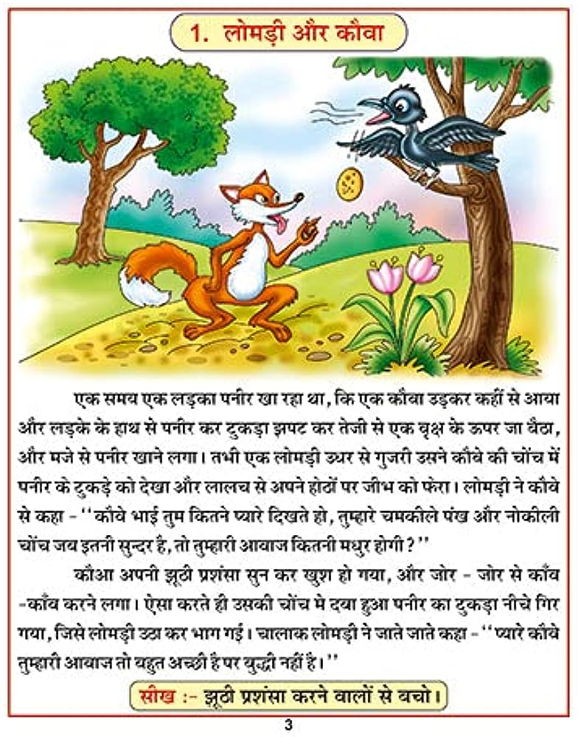
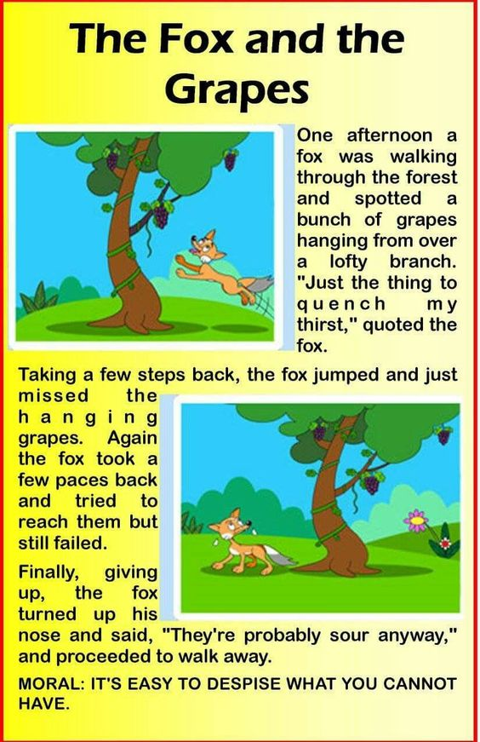
,d le; ,d yMdk iuhj [kk jgk Fkk] fd ,d dkSok mM+dj dgha ls vk;k vkSj yM+ds ds gkFk ls iuhj dk VqdM+k >iV dj rsth ls ,d o`{k ds Åij tk cSBk] vkSj ets ls iuhj [kkus yxkA rHkh ,d ykseM+h m/kj ls xqtjh mlus dkSos dh pksap esa iuhj ds VqdM+s dks ns[kk vkSj ykyp ls vius gksBksa ij thHk dks QsjkA ykseM+h us dkSos ls dgk& ÞdkSos HkkbZ rqe fdrus I;kjs fn[krs gks] rqEgkjs pedhys ia[k vkSj uqdhyh pksap tc bruh lqUnj gS] rks rqEgkjh vkokt fdruh e/kqj gksxh\Þ
dkSvk viuh >wBh iz'kalk lqu dj [kq'k gks x;k] vkSj tksj&tksj ls dk¡o&dk¡o djus yxkA ,slk djrs gh mldh pksap esa nck gqvk iuhj dk VqdM+k uhps fxj x;k] ftls ykseM+h mBk dj Hkkx xbZA pkykd ykseM+h us tkrs tkrs dgk& ÞI;kjs dkSos rqEgkjh vkokt rks cgqr vPNh gS ij cqf) ugha gSAÞ
lh[k& >wBh iz'kalk djus okyksa ls cpksA
GREENWOOD PUBLIC SCHOOL, ADITYAPURAM
OUR MOTTO - DEVELOPMENT WITH DELIGHT
SYLLABUS FOR PERIODIC-II + TERM- II (2023-24) FOR CLASS-IV
SUBJECTS | BOOKS | LESSONS |  | SKILLS |  | ACTIVITY+USE OF ICT |  | PARENTS INVOLVEMENT
ENGLISH | Longman New Images  Literature | PD-II Ch-8 How many greens are there in the park (poem), Ch-9 How the sea become salty  TERM-II Ch-11 The March to Dandi, Ch-13 Flying slippers, Ch-14 The Fifth Golden Ticket |  | Read, Understand, Pronunciation  Clarity, fluency, expression. |  | ICT – Extramarks  (All topics to be covered up on Extramarks)  Multiple Assessment:  Task-1: Reading  Task-2: Recitation  Subject Enrichment:  ASL |  | Give Your Child Regular Loud Reading Practice.
 | Writing Skills | PD-II: Writing Sentences based on the given pictures, Letter to your friend informing about your studies  TERM-II: Paragraph writing-Importance of Exercise, Sequencing the given story |  | Effective writing communication, Spelling, Handwriting, Vocabulary |  |  |  | Encourage your child to read story books.
 | Speaking Skills | Story Telling |  | Discuss, Listen, Concentrate, Recall
 | Grammar  Learnwell Smart | PD-II Ch-9 The Adverb,  Ch-10 The preposition , Ch-11 The Conjunction  TERM-II Ch-12 Question words,Ch-13 Short Forms, Ch-14 Exclamatory and Emphatic sentences, Ch-15 Some, Any, Much, Many, Ch-16 Question Tags, Jumbled Sentences |  | Comprehend,  Identify, Relate
 | Group Recitation | Ch-10 A Boy’s Song, Ch-12 I opened a Book (poem) |  |  |  |  |  | Help your child in learning poems.
 | Reading Skills | Comprehension
HINDI | mUes’k | PD-II ikB&8% rhu ;qok iafMr] ikB&9% Hkkjr ds dqN izeq[k i{kh] ikB&10% ph% pwwW cny x;k  TERM-II ikB&11% /kjrh fdruh cMh fdrkc\] ikB&12% jkLrs dk iRFkj] ikB&13% pkWn dh pksjh] ikB&14% vDyean cdjh] ikB&15% cgqr t#jh ckr |  | mPpkj.k {kerk] çokg |  | ICT- Extra Marks  (All topics to be covered up on Extramarks)  Multiple Assessment:  Task-1: Reading  Task-2: Recitation  Subject Enrichment:  Task-1: Listening Skills  Task-2: Speaking Skills |  | çfrfnu ,d ist i<+us dk vH;kl djok,aA
 | iBu dkS'ky | vifBr x|ka'k] vifBr i|ka'k] ikB iBu |  | cks/kxE;rk
 | ys[ku dkS'ky | PD-II vuqPNsn& esjk 'kgj] ;ksxk dk egRo  TERM-II vkSipkfjd i=& LFkkukarj.k izek.k i= ds fy, izkpk;kZ dks i=] foKkiu] lwpuk] laokn] fp= ys[ku] okD;ksa dks lgh Øe esa yxkb, |  | vfHkO;fDr Lrj] 'kCn p;u
 | ekSf[kd {kerk | /kjrh fdruh cMh fdrkc\ |  | Lej.k 'kfDr] vkRefo'okl |  |  |  | lqys[k fy[kok;sa
 | Jo.k {kerk | dgkuh lqukdj ç”u iwNuk |  | fo’k; dh le>] ,dkxzrk
 | O;kdj.k | PD-II fØ;k] vfodkjh 'kCn  TERM-II dky] fojkEk fpg~u] eqgkojs] foykse 'kCn] i;kZ;okph 'kCn] vusd 'kCnksa ds fy, ,d 'kCn] 'kCnksa dks lgh Øe esa yxkb, |  | O;kdjf.kd Kku]+ Hkkf"kd Kku |  |  |  | dfork ;kn djok,¡
SUBJECTS | BOOKS | LESSONS | SKILLS |  | ACTIVITY+USE OF ICT |  | PARENTS INVOLVEMENT
MATHEMATICS | Learnwell Smart | PD-II  Ch-8 Decimals, Ch-9 Length  TERM-II  Ch-10 Weight, Ch-11 Capacity, Ch-12 Time, Ch-13 Money, Ch-14 Geometry,  Ch-15 Patterns, Ch-16 Data Handling | Identify Build, Logical Thinking Decision Making |  | ICT – Extramarks  (All topics to be covered up on Extramarks)  Multiple Assessment:  Mental Maths Quiz  Subject Enrichment:  - Lab Activity |  | Make your child learn tables from (2-20)
SOCIAL SCIENCE | Longman Vistas | PD-II  Ch-12 Our Natural Resources  Ch-13 Soil of India  Ch-14 Forests of India  Ch-15 Water Resources of India  TERM-II  Ch-16 Mineral resources of India  Ch-17 Agriculture  Ch-18 Industries  Ch-19 Transport and communication  Ch-22 Our Rights and Duties  Ch-23 Our Government | Awareness,  Critical Thinking,  Understanding analysis |  | ICT – Extramarks  (All topics to be covered up on Extramarks)  Multiple Assessment:  Quiz based on the topic- Our Rights & Duties  Subject Enrichment:  Task-1: Map Work |  | Talk to your child about the ways to conserve natural resources & why water should not be wasted.
SCIENCE | Experience Science | PD-II  Ch-8 Animals and Their young ones  Ch-9 How do Animals survive  Ch-13 Our green world  TERM-II  Ch-10 Force, Work and Energy  Ch-11 The Earth and her neighbours  Ch-12 Air, Water & weather | Critical Thinking,  Appreciation, Analysis. |  | ICT – Extramarks  (All topics to be covered up on Extramarks)  Multiple Assessment:  Quiz  Subject Enrichment:  1. Lab Activity |  | Talk to your child about the animals and their survival

SUBJECTS | BOOKS | LESSONS | SKILLS | ACTIVITY+USE OF ICT | PARENTS INVOLVEMENT
COMPUTER | Cyber Beans | PD-II  Ch-5 Advanced features of Microsoft word 2010  Ch-6 Stepwise Thinking  TERM-II  Ch-7 More about scratch  Ch-8 Microsoft PowerPoint 2010  Ch-9 More on the Internet | Observation, Interaction | ICT – Extramarks  (All topics to be covered up on Extramarks)  Multiple Assessment:  Quiz based on chapters  Ch-5 Advanced features of Microsoft word 2010  Ch-6 Stepwise Thinking  Ch-7 More about scratch  Ch-8 Microsoft PowerPoint 2010  Ch-9 More on the Internet  Subject Enrichment:  Lab Activity-  1. Finding and Replacing, clipart,  2. Add new subscript, setting the script position, Rotation style  3.Playing Instruments  4.Create,save and open a presentation | Encourage your child to design or create any timetable for his/her study table using Microsoft Power Point 2010.
ART | Art & Activity | Leaf Printing | Exploration , Creative expression | -
G.K. | Be a GK Champ | PD-II  Nature and Wildlife, India, Sports  TERM-II  Science and Technology, World Around Us, Literature and Language, Art and Entertainment, Mixed Bag, Problem Solving | General Awareness | ICT- Extramarks  (All topics to be covered up on Extramarks) | Motivate your child to read English & Hindi news paper everyday.

Pkkj nksLrksa dh dgkuh
vf[kys'k] jkgqy] rstLoh] dUgS;k] ;sa pkj nksLr jkr esa ikVhZ djds okil ykSVs vkSj vxyh lqcg mudk Dykl VsLV FkkA pkjksa us rS;kjh ugha dh Fkh vkSj blfy, ,d tksjnkj Iyku cuk;k dh ge lc Mhu dks ;s cksy nsaxs dh jkLrs esa ,d ?kk;y efgyk feyh blfy, mldks gkWfLiVy ys tkuk iM+kA gkWfLiVy ys tkus dh otg ls dkWQh ysV gks x;k vkSj bl otg ls ge yksx vkt ijh{kk ns ikus dh fLrfFk esa ugha gSA
Mhu us FkksM+k lkspk vkSj pkjksa dks 'kkck'kh nh vkSj dgk dh 3 fnu ckn vkidh ijh{kk gksxhA pkjksa nksLr vius Iyku ds lQy gksus ij cgqr [kq'k gq, vkSj ml jkr Hkh ikVhZ dhA 3 fnu rd lc us te dj i<+kbZ dh vkSj ckn esa tc ijh{kk dk isij feyk rks mudh gkyr [kjkc gks x;hA isij esa dsoy nks uhps okys loky FksA
1- vkidk uke\ ¼1 vad½
2- dkSu ls gkWfLiVy esa efgyk dks HkrhZ fd;k x;k Fkk\ ¼99 vad½

dgkuh ls lh[k&
lp cksyuk T;knk Qk;nsean gksrk gSA

THE FOOLISH THIEF
One day, a wealthy man came to Akbar's court in hope to get help from Birbal. The man suspected that one of his servants had stolen from him.
The clever Birbal thought of a plan and gave all the merchant’s servants sticks of the same length. He also told them that the stick will grow three inches by tomorrow if they were the thief.
The next day, all the servants gathered around Birbal. He noticed that one of the servant’s sticks was three inches shorter than the others. Birbal immediately understood who the thief was.
The thief had cut the stick shorter by three inches as he thought it would grow three inches. Because of this his guilt was proven
Moral of the story:
The truth will always come out one way or another so better to be truthful from the beginning.

GREENWOOD PUBLIC SCHOOL, ADITYAPURAM
OUR MOTTO - DEVELOPMENT WITH DELIGHT
SYLLABUS FOR PERIODIC-II + TERM II (2023-24) FOR CLASS-V

SUBJECTS | BOOKS | LESSONS | SKILLS | ACTIVITY+USE OF ICT | PARENTS INVOLVEMENT
ENGLISH | Longman New Images  Literature | PD-II Ch-8 Can you make an App, Ch-10 A Day in the greens  TERM-II Ch-11 Underground (Poem), Ch-12 The Pied Piper of Hamelin, Ch-14 Lucy looks into a wardrobe | Using root words to locate meanings | ICT – Extramarks  (All topics to be covered up on Extramarks)  Multiple Assessment:  Task-1: Reading  Task-2: Recitation  Subject Enrichment:  ASL | Give your child regular loud reading practice.
 | Writing Skills | PD-II Paragraph – My Favourite season of the year, Notice, Writing Sentences based on the given picture  TERM-II Letter of placing order, Paragraph- The best ways to protect the environment, Sequencing the given story |  |  | Encourage your child to read story books.
 | Speaking Skills | Group Discussion  Topic-Winters are better than summers | Discuss, Listen, Concentrate, Recall
 | Grammar Learnwell Smart | 1.Imperatives and optatives, 2.change of sentences and Tenses, 3.The voice, 4.The speech, 5.Subject-Verb Agreement, 6.Requests, offers and suggestions, 7.Punctuation and Capitalization, 8.Vocabulary enrichment, Jumbled Sentences |  |  | Motivate your child to read English newspaper
 | Group Recitation | PD-II The Land of Story - Books  TERM-II- Underground, The Bobble who has no Toes |  |  | Help your child in learning poems.
 | Reading Skills | Comprehension
HINDI | mUes’k | PD-II ikB&8% viuk Hkkjr I;kjk gS ] ikB&9% Hkkjr dh izeq[k ufn;kW ] ikB&10% ,d YkMdh ftls fdrkcksa ls uQjr Fkh  TERM-II ikB&11% jkTkk vkSj ukfod ] ikB&12 fdrkcksa dh nqfu;k] ikB&13% e”khUk okyk gkFkh] ikB&14% xq#Ro& “kfDr ] ikB&15 if{k;ksa dk dfo lEesyu | mPpkj.k {kerk]izokg | ICT- Extra Marks  (All topics to be covered up on Extramarks)  Multiple Assessment:  Task-1: Reading  Task-2: Recitation  Subject Enrichment:  ASL | izfrfnu ikB i<+ok,¡
 | iBu dkS'ky | vifBr x|ka”k] vifBr i|ka”k | cks/kxE;rk
 | ys[ku dkS'ky | PD-II vkSipkfjd i=& lsD'ku cnyokus ds fy, izkpk;kZ dks izkFkZuk i=] vuqPNsn& ty gh thou gS] le; dk lnqi;ksx  TERM-II foKkiu] lwpuk] fp= o.kZu] okD;ksa dks lgh dze esa yxkb, | vfHkO;fDr Lrj] 'kCnp;u |  | ys[ku dk vH;kl djok,as
 | ekSf[kd {kerk | PD-II fdrkckas dh nqfu;k  TERM-II xq:Ro 'kfDr | Lej.k 'kfDr] vkRefo'okl |  | dfork ;kn djok,¡
 | Jo.k {kerk | dgkuh lqukdj iz'u iwNuk | fo’k; dh le>],dkxzrk |  | dgkuh lqukdj iz'uiwNsa
 | O;kdj.k | PD-II fo”ks’k.k dh ifjHkk’kk] fØ;k dh ifjHkk’kk] foykse 'kCn] opu cnyks] TERM-II fyax cnyks] i;kZ;okph 'kCn] vusd 'kCnks ds fy, ,d 'kCn] Ekqgkojs] fojke fpgu] dky] 'kCnksa dks lgh dze es yxkb, | O;kdjf.kd Kku]+ Hkkf"kd Kku

SUBJECTS | BOOKS | LESSONS | SKILLS | ACTIVITY+USE OF ICT | PARENTS INVOLVEMENT
MATHEMATICS | Interactive Mathematics | PD-II  Ch-8 : Length  Ch-9: Weight  Ch-10 Capacity  TERM-II  Ch- 11 Time and Temperature  Ch-12 Money  Ch-13 Area & Perimeter  Ch-14 Volume  Ch-15 Geometry  Ch-16 Patterns  Ch-17 Data Handling & Average | Identify Build,  Logical Thinking,  Decision Making | ICT – Extramarks  (All topics to be covered up on Extramarks)  Multiple Assessment:  Task-1: Mental Maths Quiz  Subject Enrichment:  Lab Activity | Make your child learn tables from 2-20
SOCIAL SCIENCE | New Longman vistas | PD-II  Ch-12 Natural Disasters  Ch-13 Transmitting knowledge  Ch-17 Some Great Indians  Ch-16 Great world leaders  TERM-II  Ch-14 Transport and communication  Ch-15 Medicines  Ch-18 The coming of the British  Ch-19 The freedom struggle  Ch-20 The Indian government  Ch-21 The united Nations | Awareness,  Critical Thinking,  Creative Writing | ICT – Extramarks  (All topics to be covered up on Extramarks)  Multiple Assessment: Quiz on “Some Great Indians”  Subject Enrichment:  Map Work | Show movies/stories on Great Indian Freedom Fighters.
SCIENCE | Frank Experience Schience | PD-II  Ch-8 The world of Animals  Ch-9 Bones and Muscles  Ch-15 Our environment  TERM-II  Ch-10 The Nervous system  Ch-11 Force and energy  Ch-12 Air and water  Ch-13 The Earth’s Satellites  Ch-14 Natural Disasters | Critical Thinking,  Appreciation  Analysis | ICT – Extramarks  (All topics to be covered up on Extramarks)  Multiple Assessment:  MCQ based quiz on the topic – ‘Nervous System’  Subject Enrichment:  1. Lab Activity- To show air is essential for burning  2. Lab Activity- To show that air exerts pressure | Discuss with your child the importance of Environment

SUBJECTS | BOOKS | LESSONS | SKILLS | ACTIVITY+USE OF ICT | PARENTS INVOLVEMENT
COMPUTER | Computer Beans | PD-II  Ch-5 Microsoft PowerPoint  Ch-6 Slides organisation in PowerPoint  TERM-II  Ch-7 Formatting a presentation  Ch-8 Programming in scratch  Ch-9 Internet-Online surfing | Observation,  Interaction | ICT – Extramarks  (All topics to be covered up on Extramarks)  Multiple Assessment:  Quiz based on Chapters  Ch-5 Microsoft PowerPoint  Ch-9 Internet – Online surfing  Subject Enrichment:  Lab Activity-  1. Creating a presentation  2. Insert Smart Art, Clipart  3. Changing the slide layout  4. Copying , Moving, Resizing, Rotating on object  5. Working with slide master  6. Use of sensing Blocks, using Mathematical operators, Making a variable  7. Create Script | Encourage your child to read and write daily one page.
ART | Art & Activity | Scenery,  Landscape | Exploration , Creative Expression
G.K | Be a GK Champ | PD-II  Unit - 10 Nature and Wildlife,  Unit- 11 India, Unit-12 Sports  TERM-II  Unit-13 Science and Technology, Unit-14 World Around us, Unit-15 Literature and Language, Unit-16 Art and Entertainment, Unit-17 Mixed Bag, Unit-18 Problem Solving | Logical thinking | Quiz based on Current affairs.

The King’s Painting
There was a king with only one leg and one eye but was generous and competent as a ruler. One day while walking in his palace, the king noticed the portraits of his ancestors along the hallway. He also wanted his portrait painted by an artist but was unsure how it would turn out due to his physical abnormalities. The King invited all the painters across the kingdoms and asked who could paint a beautiful picture of him. The painters were confused about how to make a beautiful picture of the King with only one leg and one eye.
All the painters politely refused to make a painting of the King. Then one young painter came forward and ensured to make a beautiful portrait of the King. After a few days, the young painter unveiled the portrait in the court in which the King was seen sitting on the horse with one leg visible, holding his bow and aiming the arrow with one eye closed. There was no sign of physical deficiencies in the king in the painting. The King was pleased to see that the painter had creatively presented the King’s positive characteristics but not highlighted the abnormalities.
Moral: Look at the positive aspects of someone without emphasizing the limitations.

गँवार किसान
एक किसान था। वह पढ़ा-लिखा नहीं था। वह अकसर लोगों को अखबार व किताबें पढने के लिए चश्मा लगाते देखा करता था। वह सोचता, अगर मेरे पास भी चश्मा होता, तो मैं भी इन लोगों की तरह पढ़ सकता। मुझे भी शहर जाकर अपने लिए चश्मा खरीद लाना चाहिए। एक दिन वह शहर गया। चश्मे की एक दुकान में पहुँचकर उसने दुकानदार से कहा कि मुझे पढ़ने के लिए चश्मा चाहिए। दुकानदार ने उसे तरह-तरह के चश्मे दिखाए।
उसने पढ़ने के लिए उसे एक पुस्तक भी दी। किसान ने एक-एक कर अनेक चश्मे लगाकर देखे। पर वह कुछ भी नहीं पढ़ सका। उसने दुकानदार से कहा, इसमें से कोई भी चश्मा मेरे काम का नहीं है। दुकानदार ने शंकाभरी नजर से किसान की ओर देखा। फिर उसकी नजर किताब पर पड़ी। किसान ने किताब उल्टी पकड़ रखी थी। दुकानदार ने कहा, शायद तुम्हें पढ़ना नहीं आता? किसान ने कहा, मुझे पढ़ना नहीं आता।
इसीलिए तो मैं चश्मा खरीद रहा हूँ, ताकि दूसरों की तरह मैं भी पढ़ सकूँ। पर इनमें से किसी भी चश्मे से मैं पढ़ नहीं पा रहा हूँ। दुकनदार को अपने अनपढ़ ग्राहक की असली परेशानी का पता चला। तो वह बड़ी मुश्किल से अपनी हँसी रोक सका। उसने किसान को समझाते हुए कहा, मेरे दोस्त, तुम बहुत भोले और अज्ञानी हो।
सिर्फ चश्मा लगा लेने भर से किसी को पढ़ना-लिखना नहीं आ जाता। चश्मा लगाने से सिर्फ साफ-साफ दिखाई देने लगता है। पहले तुम पढ़ना-लिखना तो सीखो। फिर तुम्हें बिना चश्मे के भी पढ़ना आ जाएगा।
Moral – अज्ञान ही अंधत्व है।

